Design Architecture (Store Word Instruction)
Introduction
Store instructions are S-type instructions. The store word instruction, sw, copies data from
a register to memory. The register is not changed. The memory address is specified using a
base/register pair. The name S-type is short for Store-type. S-type instructions use two
register operands and one immediate operand. The figure below shows the S-type machine
instruction format. The 32-bit instruction has five fields: op, rs1, rs2, funct3, and imm. The
first four fields, op, rs1, rs2, and funct3 are like those of R-type instructions. The imm field
holds the 12-bit immediate. The operation is determined by the opcode and funct3,
highlighted in blue. The operands are specified in the three fields rs1, rs2, and imm. rs and
imm are always used as source operands. rs2 is used as another source for store instructions.

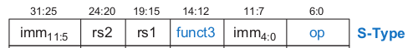

Like I-type instructions, S-type also has 12-bit immediates. The immediate in store
instructions are split into two halves: the lower bits are stored in Instr[11:7] bit and the upper
bits are stored in Instr[31:25]. First, we make the 12-bit immediate by concatenating the
upper and lower part of immediate and then sign extend it for further use.

DataPath for Store Word Instruction
In this section, we will extend the data path to Store instructions. Like the load instruction,
the store instruction reads a base address from port 1 of the register file and sign-extends an
immediate. The ALU adds the base address to the immediate to find the memory address. All
of these functions are already supported by the datapath. The store instruction also reads a
second register from the register file and writes it to the data memory. The figure below
shows the new connections for this function. The register is specified in the rs2 field,
Instr[24:20]. These bits of the instruction are connected to the second register file read port,
A2.
The register value is read onto the RD2 port. It is connected to the write data port of the data
memory. The write enable port of the data memory, WE are controlled by MemWrite. For a
store instruction, MemWrite = 1, to write the data to memory; ALUControl = 000, to add the
base address and offset; and RegWrite = 0, because nothing should be written to the register
file. Note that data is still read from the address given to the data memory, but that this
ReadData is ignored because RegWrite = 0.

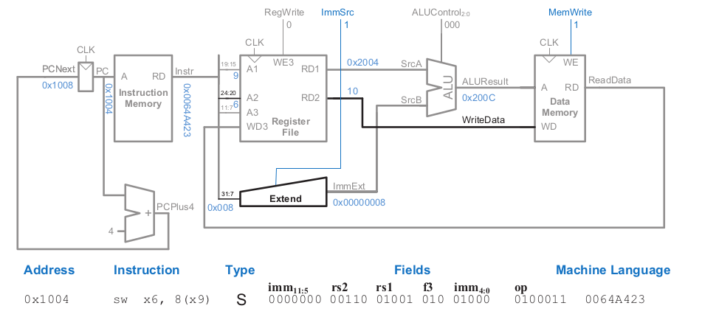
For check other instruction goto venus and run assembly to get machine code. The following example given below.
 | PC | Machine Code | Basic Code | Original Code
 | 0x0 | 0x02800593 | addi x11 x0 40 | addi x11,x0,0x28
 | 0x4 | 0x03000613 | addi x12 x0 48 | addi x12,x0,0x30
 | 0x8 | 0x00B62423 | sw x11 8(x12) | sw x11,0x8(x12)

0x1004 sw x11, 8(x12) S 0000000 00110 01001 010 01000 0100011 00B62423

